Name: Purval Madhukar Bhude

Roll no : S20230010193

Subject : Cp

Assignment 11 graded assignment 03 (on structures)

Question 1

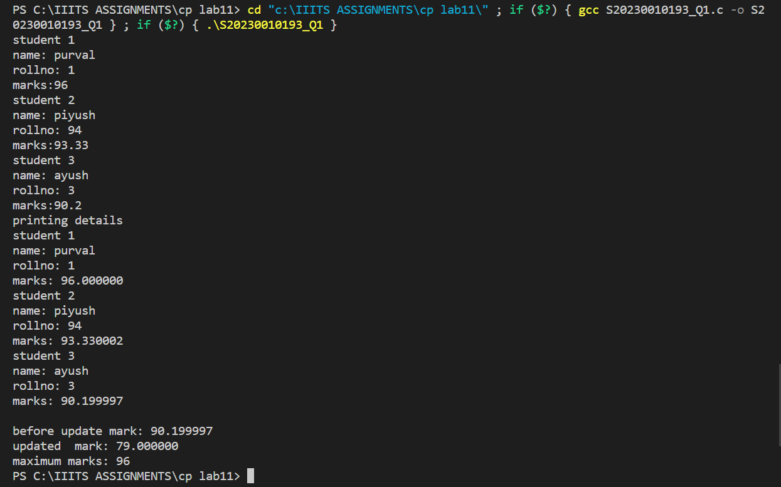

Question 2

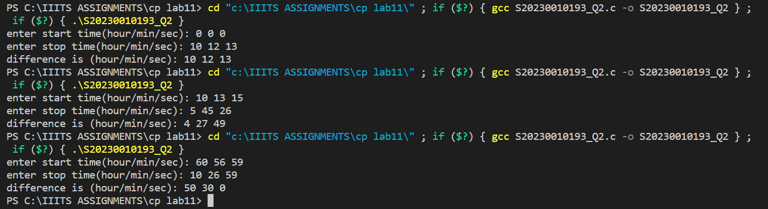

Question 3

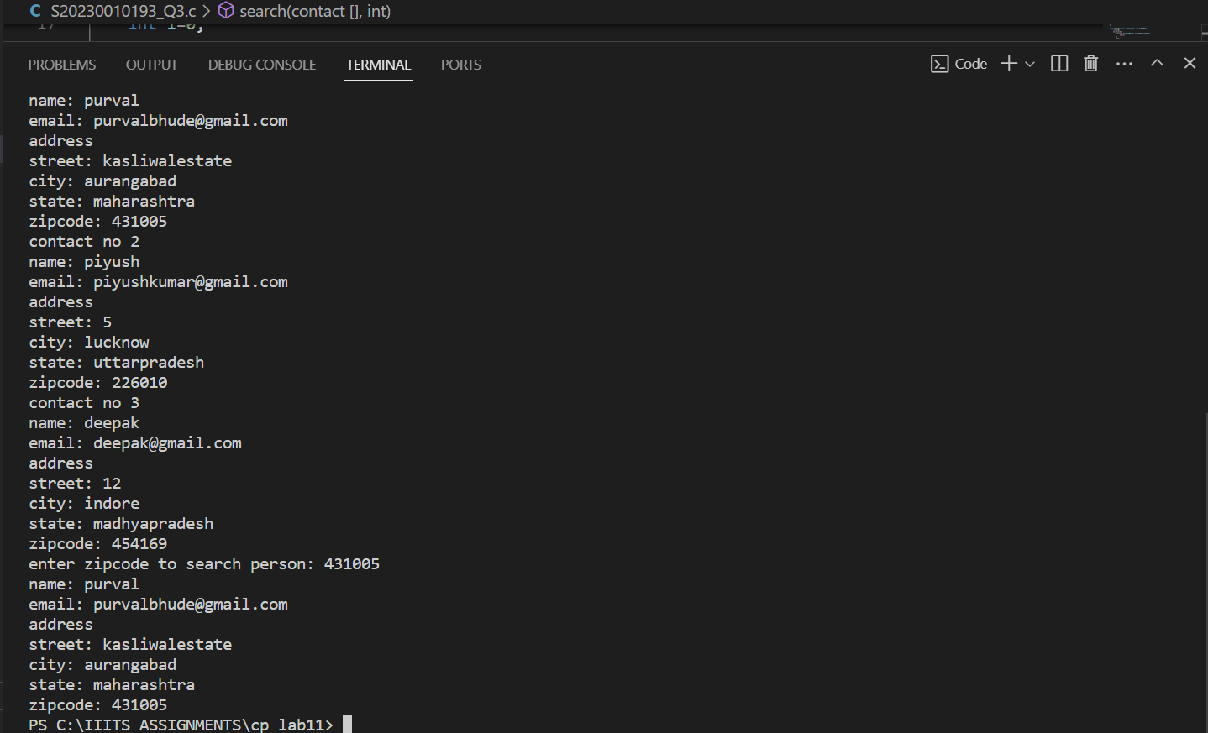

Question 4

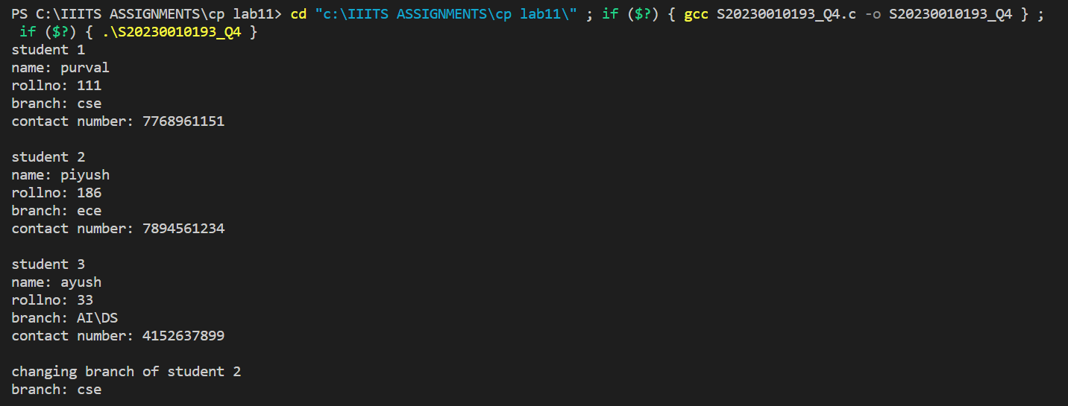

Question 5

